35.2: a) At 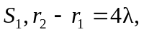and this path difference stays the same all along the 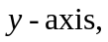so 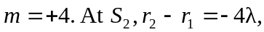 and the path difference below this point, along the negative -axis, stays the same, so 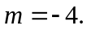
b)

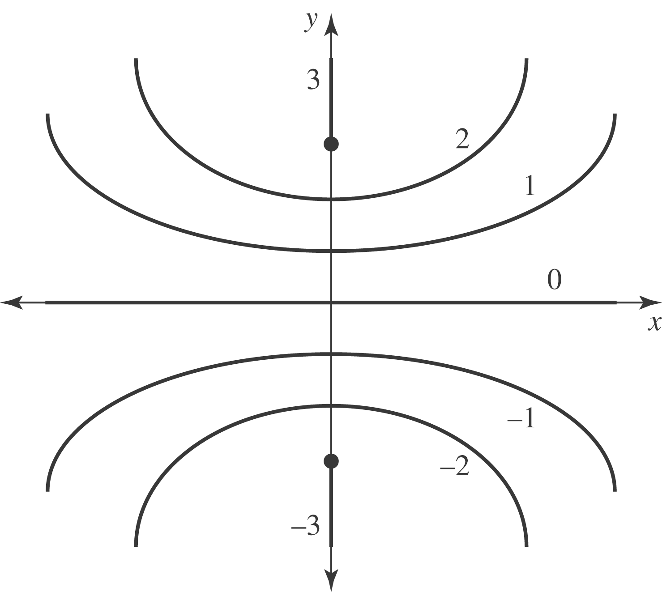

c) The maximum and minimum m-values are determined by the largest integer less than or equal to 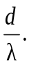
d) If 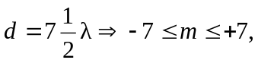 so there will be a total of 15 antinodes between the sources. (Another antinode cannot be squeezed in until the separation becomes six times the wavelength.)

